Inscribed Angle Theorem
# Source: AI Source: Provided by: [Data Path: Persons Table -> ID Column: 1, Name_En Column: Motasem Essam] -> From: [ChatGPT] on [7/25/2026]
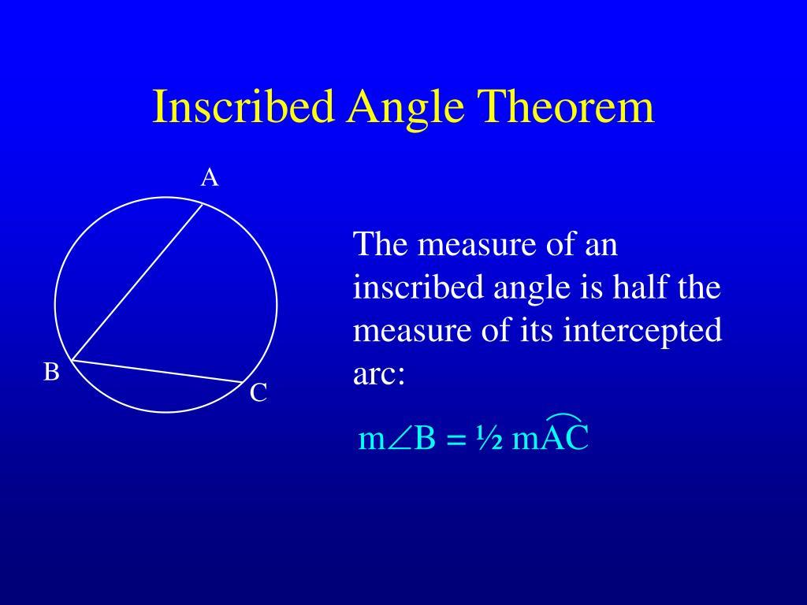
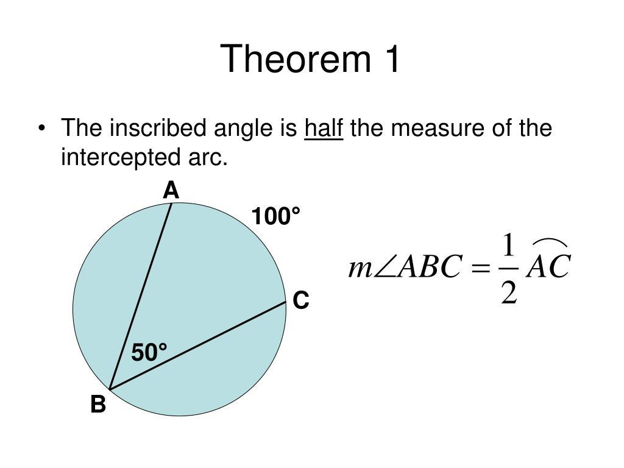
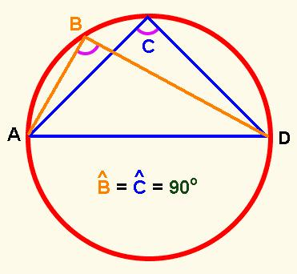
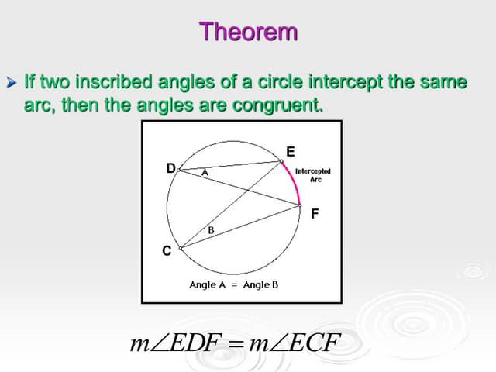
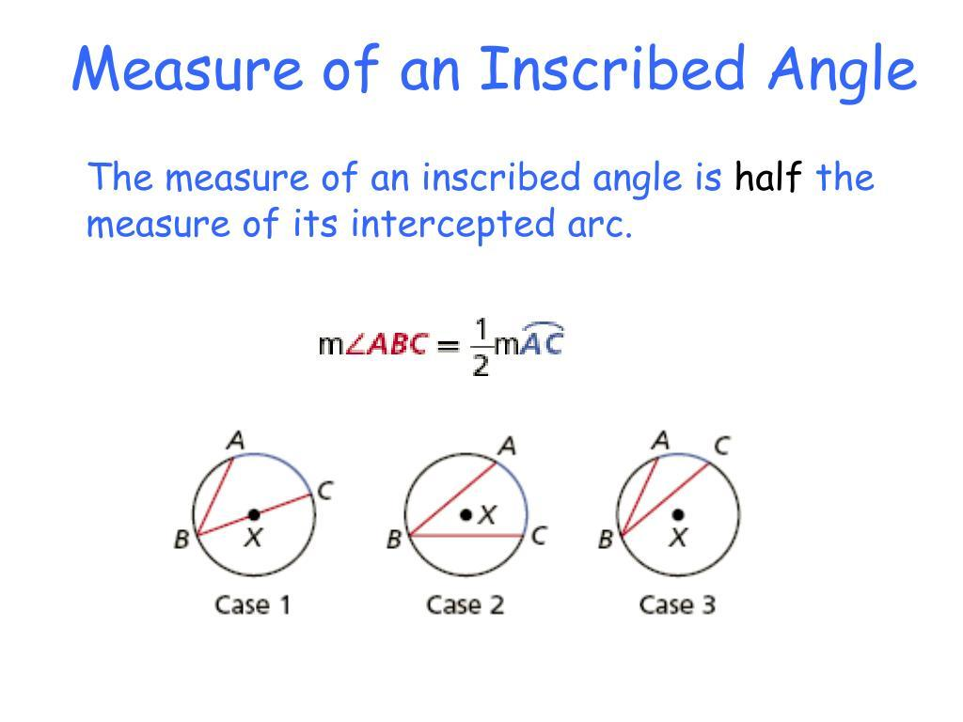

Definition
# Source: AI Source: Provided by: [Data Path: Persons Table -> ID Column: 1, Name_En Column: Motasem Essam] -> From: [ChatGPT] on [7/25/2026]
The Inscribed Angle Theorem states that the measure of an inscribed angle is equal to half the measure of its intercepted arc.
If $A$, $B$, and $C$lie on a circle, then $∠ACB$is an inscribed angle that intercepts arc $\hat{AB}$:
$$\boxed{m\left(∠ACB\right)=\frac{1}{2}m\left(\hat{AB}\right)}$$
Equivalently:
$$\boxed{m\left(\hat{AB}\right)=2m\left(∠ACB\right)}$$

Fundamental Concept
# Source: AI Source: Provided by: [Data Path: Persons Table -> ID Column: 1, Name_En Column: Motasem Essam] -> From: [ChatGPT] on [7/25/2026]
An inscribed angle has:
- its vertex on the circumference of the circle;
- two sides that are chords of the circle.
The arc lying opposite the vertex and bounded by the endpoints of the angle is its intercepted arc.
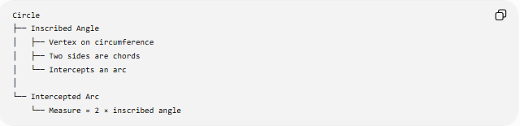
Circle
├── Inscribed Angle
│ ├── Vertex on circumference
│ ├── Two sides are chords
│ └── Intercepts an arc
│
└── Intercepted Arc
└── Measure = 2 × inscribed angle
The fundamental relationship is:
$$\boxed{\text{Inscribed Angle}=\frac{1}{2}\left(\text{Intercepted Arc}\right)}$$

Theorem Statement
# Source: AI Source: Provided by: [Data Path: Persons Table -> ID Column: 1, Name_En Column: Motasem Essam] -> From: [ChatGPT] on [7/25/2026]
# Source: AI Source: Provided by: [Data Path: Persons Table -> ID Column: 1, Name_En Column: Motasem Essam] -> From: [ChatGPT] on [7/25/2026]
For an inscribed angle $∠ACB$intercepting arc $\hat{AB}$:
$$\boxed{m\left(∠ACB\right)=\frac{1}{2}m\left(\hat{AB}\right)}$$
For example, if:
$$m\left(\hat{AB}\right)={80}^{∘}$$
then:
$$m\left(∠ACB\right)=\frac{1}{2}\left({80}^{∘}\right) \\ \boxed{m\left(∠ACB\right)={40}^{∘}}$$

Main Parts
# Source: AI Source: Provided by: [Data Path: Persons Table -> ID Column: 1, Name_En Column: Motasem Essam] -> From: [ChatGPT] on [7/25/2026]
For $∠ACB$:
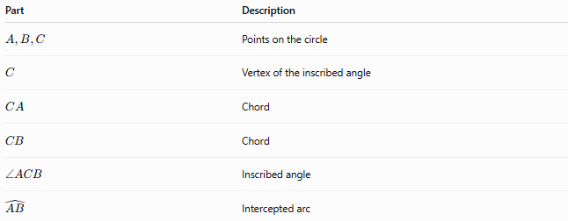
Part | Description
$$A,B,C$$ | Points on the circle
$$C$$ | Vertex of the inscribed angle
$$CA$$ | Chord
$$CB$$ | Chord
$$∠ACB$$ | Inscribed angle
$$\hat{AB}$$ | Intercepted arc
The angle and arc satisfy:
$$\boxed{m\left(∠ACB\right)=\frac{1}{2}m\left(\hat{AB}\right)}$$

Relationship to the Central Angle Theorem
# Source: AI Source: Provided by: [Data Path: Persons Table -> ID Column: 1, Name_En Column: Motasem Essam] -> From: [ChatGPT] on [7/25/2026]
The Inscribed Angle Theorem is closely related to the Central Angle Theorem.
For the same intercepted arc $\hat{AB}$:
$$m\left(∠AOB\right)=m\left(\hat{AB}\right)$$
while:
$$m\left(∠ACB\right)=\frac{1}{2}m\left(\hat{AB}\right)$$
Therefore:
$$\boxed{m\left(∠AOB\right)=2m\left(∠ACB\right)}$$
where:
- $∠AOB$= central angle;
- $∠ACB$= inscribed angle.

Inscribed Angles Intercepting the Same Arc
# Source: AI Source: Provided by: [Data Path: Persons Table -> ID Column: 1, Name_En Column: Motasem Essam] -> From: [ChatGPT] on [7/25/2026]
Two inscribed angles that intercept the same arc have equal measures.
If both $∠ACB$and $∠ADB$intercept $\hat{AB}$, then:
$$\boxed{m\left(∠ACB\right)=m\left(∠ADB\right)}$$
This is sometimes called the Same Arc Inscribed Angle Theorem.

Inscribed Angles in the Same Segment
# Source: AI Source: Provided by: [Data Path: Persons Table -> ID Column: 1, Name_En Column: Motasem Essam] -> From: [ChatGPT] on [7/25/2026]
Inscribed angles subtending the same chord from the same side of the chord are equal.
If:
$$∠ACB$$
and:
$$∠ADB$$
subtend chord $\overset{‾}{AB}$from the same segment, then:
$$\boxed{∠ACB≅∠ADB}$$
This is commonly known as the Angles in the Same Segment Theorem.

Special Case — Diameter
# Source: AI Source: Provided by: [Data Path: Persons Table -> ID Column: 1, Name_En Column: Motasem Essam] -> From: [ChatGPT] on [7/25/2026]
When an inscribed angle intercepts a diameter, its intercepted arc is a semicircle.
Therefore:
$$m\left(\hat{AB}\right)={180}^{∘}$$
and:
$$m\left(∠ACB\right)=\frac{1}{2}\left({180}^{∘}\right)$$
so:
$$\boxed{m\left(∠ACB\right)={90}^{∘}}$$
This is Thales' theorem.
Thales' Theorem
An angle subtended by a diameter at the circumference of a circle is a right angle.
$$\boxed{\text{Diameter intercepted}⟹{90}^{∘}\text{ inscribed angle}}$$

Classification by Intercepted Arc
# Source: AI Source: Provided by: [Data Path: Persons Table -> ID Column: 1, Name_En Column: Motasem Essam] -> From: [ChatGPT] on [7/25/2026]
The intercepted arc determines the type of inscribed angle.
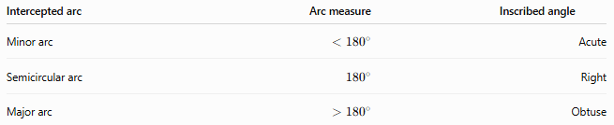
Intercepted arc | Arc measure | Inscribed angle
Minor arc | $$<{180}^{∘}$$ | Acute
Semicircular arc | $${180}^{∘}$$ | Right
Major arc | $$>{180}^{∘}$$ | Obtuse
For example:
Minor arc
$$m\left(\hat{AB}\right)={100}^{∘}$$
Then:
$$m\left(∠ACB\right)={50}^{∘}$$
Semicircular arc
$$m\left(\hat{AB}\right)={180}^{∘}$$
Then:
$$m\left(∠ACB\right)={90}^{∘}$$
Major arc
$$m\left(\hat{AB}\right)={240}^{∘}$$
Then:
$$m\left(∠ACB\right)={120}^{∘}$$

Important Relationship with Central Angles
# Source: AI Source: Provided by: [Data Path: Persons Table -> ID Column: 1, Name_En Column: Motasem Essam] -> From: [ChatGPT] on [7/25/2026]
For the same arc:
$$\boxed{m\left(\text{central angle}\right)=m\left(\text{arc}\right)=2m\left(\text{inscribed angle}\right)}$$
Therefore:
$$\boxed{m\left(\text{inscribed angle}\right)=\frac{1}{2}m\left(\text{central angle}\right)}$$
This provides a convenient way to solve many circle-angle problems.

Example 1 — Finding an Inscribed Angle
# Source: AI Source: Provided by: [Data Path: Persons Table -> ID Column: 1, Name_En Column: Motasem Essam] -> From: [ChatGPT] on [7/25/2026]
Suppose:
$$m\left(\hat{AB}\right)={120}^{∘}$$
An inscribed angle intercepts this arc.
Using the theorem:
$$m\left(∠ACB\right)=\frac{1}{2}\left({120}^{∘}\right) \\ \boxed{m\left(∠ACB\right)={60}^{∘}}$$

12. Example 2 — Finding an Intercepted Arc
Suppose:
$$m\left(∠ACB\right)={35}^{∘}$$
Then:
$$m\left(\hat{AB}\right)=2\left({35}^{∘}\right) \\ \boxed{m\left(\hat{AB}\right)={70}^{∘}}$$

13. Example 3 — Using a Diameter
Suppose $AB$is a diameter and $C$is any point on the circle.
Then the intercepted arc is a semicircle:
$$m\left(\hat{AB}\right)={180}^{∘}$$
Therefore:
$$m\left(∠ACB\right)=\frac{1}{2}\left({180}^{∘}\right) \\ \boxed{m\left(∠ACB\right)={90}^{∘}}$$
Thus:
$$\boxed{∠ACB\text{ is a right angle}}$$

Example 4 — Two Inscribed Angles
# Source: AI Source: Provided by: [Data Path: Persons Table -> ID Column: 1, Name_En Column: Motasem Essam] -> From: [ChatGPT] on [7/25/2026]
Suppose:
$$m\left(∠ACB\right)={42}^{∘}$$
and $∠ADB$intercepts the same arc $\hat{AB}$.
Therefore:
$$\boxed{m\left(∠ADB\right)={42}^{∘}}$$
Both angles are equal because they intercept the same arc.

Example 5 — Finding a Missing Angle
# Source: AI Source: Provided by: [Data Path: Persons Table -> ID Column: 1, Name_En Column: Motasem Essam] -> From: [ChatGPT] on [7/25/2026]
Suppose an inscribed angle intercepts an arc measuring:
$${150}^{∘}$$
Then:
$$x=\frac{{150}^{∘}}{2} \\ \boxed{x={75}^{∘}}$$

Inscribed Angle vs. Central Angle
# Source: AI Source: Provided by: [Data Path: Persons Table -> ID Column: 1, Name_En Column: Motasem Essam] -> From: [ChatGPT] on [7/25/2026]
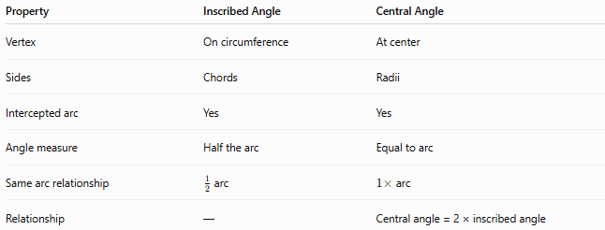
Property | Inscribed Angle | Central Angle
Vertex | On circumference | At center
Sides | Chords | Radii
Intercepted arc | Yes | Yes
Angle measure | Half the arc | Equal to arc
Same arc relationship | $\frac{1}{2}$arc | $1×$arc
Relationship | — | Central angle = 2 × inscribed angle

Inscribed Angle vs. Arc
# Source: AI Source: Provided by: [Data Path: Persons Table -> ID Column: 1, Name_En Column: Motasem Essam] -> From: [ChatGPT] on [7/25/2026]
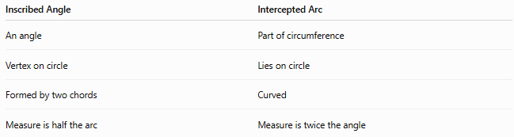
Inscribed Angle | Intercepted Arc
An angle | Part of circumference
Vertex on circle | Lies on circle
Formed by two chords | Curved
Measure is half the arc | Measure is twice the angle
$$\boxed{m\left(∠\right)=\frac{1}{2}m\left(\overset{^}{\text{arc}}\right)}$$

Classification
# Source: AI Source: Provided by: [Data Path: Persons Table -> ID Column: 1, Name_En Column: Motasem Essam] -> From: [ChatGPT] on [7/25/2026]
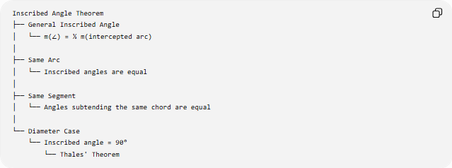
Inscribed Angle Theorem
├── General Inscribed Angle
│ └── m(∠) = ½ m(intercepted arc)
│
├── Same Arc
│ └── Inscribed angles are equal
│
├── Same Segment
│ └── Angles subtending the same chord are equal
│
└── Diameter Case
└── Inscribed angle = 90°
└── Thales' Theorem

Important Properties
# Source: AI Source: Provided by: [Data Path: Persons Table -> ID Column: 1, Name_En Column: Motasem Essam] -> From: [ChatGPT] on [7/25/2026]
- The vertex of an inscribed angle lies on the circumference.
- Its two sides are chords of the circle.
- The intercepted arc lies opposite the vertex.
- The inscribed angle measures half its intercepted arc:
$$\boxed{m\left(∠\right)=\frac{1}{2}m\left(\overset{^}{\text{arc}}\right)}$$
- The central angle subtending the same arc is twice the inscribed angle.
- Inscribed angles intercepting the same arc are equal.
- An angle subtending a diameter is ${90}^{∘}$.
- A minor arc produces an acute inscribed angle.
- A semicircular arc produces a right inscribed angle.
- A major arc produces an obtuse inscribed angle.

Applications
# Source: AI Source: Provided by: [Data Path: Persons Table -> ID Column: 1, Name_En Column: Motasem Essam] -> From: [ChatGPT] on [7/25/2026]
The Inscribed Angle Theorem is used in:
- Circle geometry
- Angle calculations
- Chord and arc problems
- Cyclic quadrilaterals
- Thales' theorem
- Tangent–chord relationships
- Circle constructions
- Coordinate geometry
- Engineering and CAD
- Computer graphics

Key Formula Summary
# Source: AI Source: Provided by: [Data Path: Persons Table -> ID Column: 1, Name_En Column: Motasem Essam] -> From: [ChatGPT] on [7/25/2026]
Inscribed Angle Theorem
$$\boxed{m\left(∠ACB\right)=\frac{1}{2}m\left(\hat{AB}\right)}$$
Finding the arc
$$\boxed{m\left(\hat{AB}\right)=2m\left(∠ACB\right)}$$
Central and inscribed angles
$$\boxed{m\left(∠AOB\right)=2m\left(∠ACB\right)}$$
Diameter case
$$\boxed{AB\text{ is a diameter}⟹∠ACB={90}^{∘}}$$
Same intercepted arc
$$\boxed{∠ACB=∠ADB}$$
when both angles intercept the same arc under the appropriate same-segment configuration.

Conclusion
# Source: AI Source: Provided by: [Data Path: Persons Table -> ID Column: 1, Name_En Column: Motasem Essam] -> From: [ChatGPT] on [7/25/2026]
The Inscribed Angle Theorem establishes the fundamental relationship between an angle whose vertex lies on a circle and the arc it intercepts:
$$\boxed{m\left(∠ACB\right)=\frac{1}{2}m\left(\hat{AB}\right)}$$
It is closely connected to the Central Angle Theorem, the Same Segment Theorem, and Thales' theorem. In particular, an inscribed angle subtending a diameter is always a right angle, making the theorem one of the most important tools in circle geometry.

